Engineering College, Ajmer
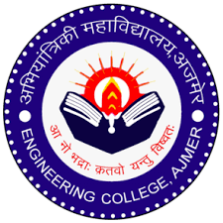
Creative Art Society
Notice Date: 6/10/21
The final year students are hereby invited to give their names for selection of advisor for smooth conduction of various activities which will be conducted in session 21-22 by CAS. The interested students are required to fill the spreadsheet (link is given below). The selection criteria which will be validated by production of certificates by them on date of selection by committee, Creative Art Society. Date of selection will be announced soon.
Pooja Tomar
Convener CAS
Link of spread sheet: https://docs.google.com/spreadsheets/d/1UsO0dfRlU0_iq5GmbrHVg6q-N3UpSz8iZuTTLoxFJW0/edit#gid=0

